

C

How to spot a mink
Please refer to the Waterlife Recovery Trust website for information about mink or to record a sighting. This organisation is co-ordinating a UK wide monitoring programme.
More can be found here: https://www.waterliferecoverytrust.org.uk/report-a-sighting/ Trust
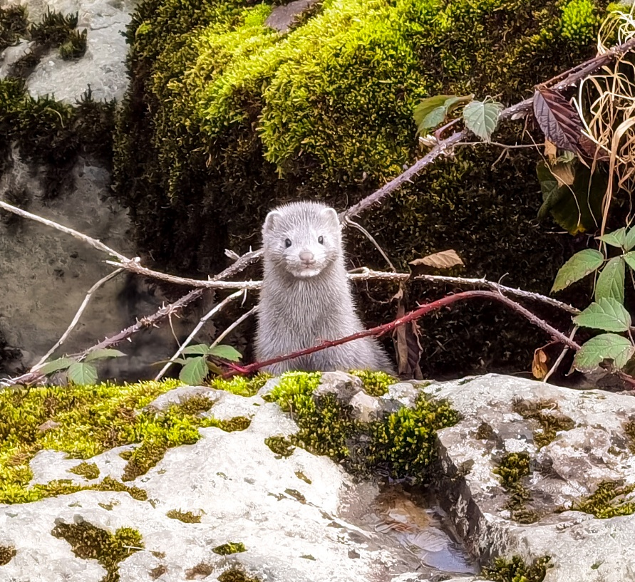
Image credit: WRT

- Size: Around 45-60 cm (nose to tail)
- Weight: Around 750-1,500 grams
- Colour: Typically dark brown, almost black
- Tail: Long and fluffy when dry
- Diet: Eats a variety of birds, fish, invertebrates, reptiles, and small mammals, including the endangered water vole

Identification
They typically have dark brown fur, which can appear black when wet, along with a small, narrow nose and a long fluffy tail. They can occasionally be other colours, such as black, grey, white, or even a morph that is white with black markings. They generally have a vibrant white patch on the chin, though not always, and can also have white markings on the throat, chest, and abdomen, which are more visible on a carcass.
A mink is similar in size to a ferret or polecat, but larger than a stoat or weasel, and much smaller than a fully-grown otter.

Another useful site for information is the Game and Wildlife Conservation Trust: https://www.gwct.org.uk/

