Forest School training
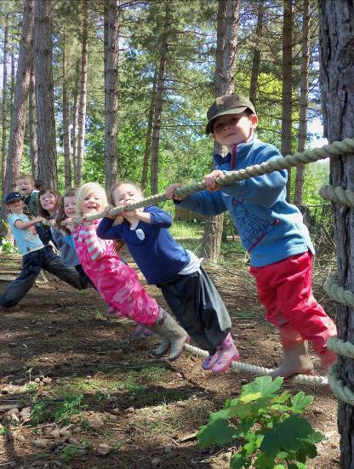

Whether you’re looking for a Level 3 Forest School leader course, want to find out a bit more about the
Forest School ethos or would like to develop your practical skills to support learning outside the classroom, the Trust offers a range of adult learning opportunities across Hampshire and the Isle of Wight delivered in our beautiful woodland nature reserves and staffed by a team of experienced professionals.

Why choose the Wildlife Trust?
By opting to train with the Hampshire and Isle of Wight Wildlife Trust, you are not only supporting your local wildlife charity but also initiating a new supportive relationship on the journey to becoming an inspiring Forest School Leader.

Our tutors are experts in biodiversity protection and ecological management of education sites. We have a wealth of experience to share from delivering Forest School in a range of environments, to early years groups, different key stage school groups, through to adults and special educational needs groups.
Our tutors can offer you individual support, feedback and advice throughout your training and beyond- our close ties to the local FSA Hampshire group enables us to mentor and skill share with the local Forest School community beyond initial leadership training. Our tutors are active members of the Forest School Association (FSA) ensuring our delivery and assessment quality remains current and of high quality. Our training programme enables our certificated trainees to apply for the FSA Accredited Forest School Provider scheme.
© Deryn Hawkins

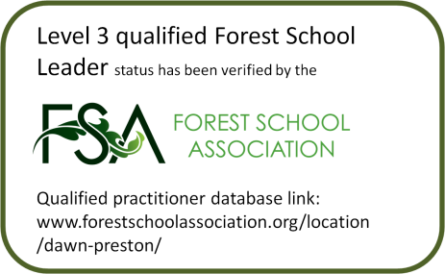
Forest School Association
This is the professional body of Forest School practitioners and should be the first port of call for independent information and advice about Forest School in the UK. Forest School trainees studying accredited level 1, 2 or 3 courses are eligible for a discounted membership of the Forest School Association (the professional body for Forest School practitioners). We will give you further details of this offer during the training.

Meet the Trust’s Forest School training team
Hampshire and Isle of Wight Wildlife Trust first started to deliver Forest School to local schools and community groups in 2007 as part of their environmental education programme. The Trust’s education service holds the Quality Badge from the Council for Learning Outside the Classroom and is a member of the Forest School Trainers’ Network. All our Education team are DBS checked and have completed Outdoor First Aid training. If you would like to know more about Forest School training with Hampshire and Isle of Wight Wildlife Trust, you can find information on our website or speak to a member of our Forest School training team. www.hiwwt.org.uk/events
If you have any queries or require further information, please contact Hampshire and IOW Wildlife Trust on 01489 774406 or email forestschool@hiwwt.org.uk

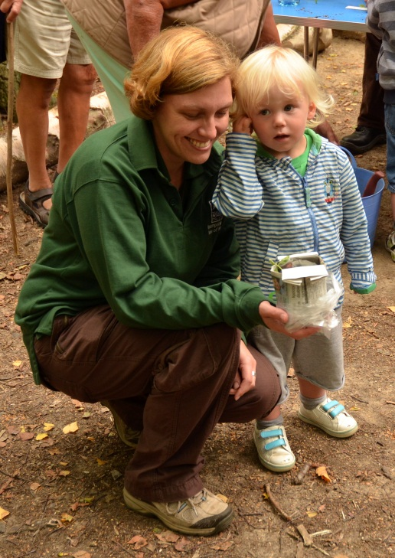
Dawn Preston
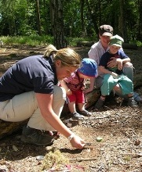
‘’Dawn’s knowledge and expertise is delivered in a calm and confident manner making her a naturally inspiring person and superb tutor, trainer and education officer. Her attention to detail through the teaching and tutoring process from administration to the individuals needs in the outdoors never waivers and this level of attention is evident for the youngest of learners to the eldest. Her ability to deliver in this style is representative of her reflective style in practice and is carried forward from her Forest School training and experience working with trainers and education staff across the region. Working with Dawn as with other Trust education staff is an education itself with many ideas and practices positively shared, an ethos evident within the Wildlife Trust. Dawn has been key in driving the Wildlife Trust forward to become a Forest School training provider in the region and to ensure it delivers the highest quality training; alongside this Dawn is key in developing the local FSA Hampshire cluster group.’’ Adrian Goodhand
Dawn O’Malley
“Dawn is passionate about outdoor play and this has naturally led her to becoming a Forest School Leader. Dawn is equally enthusiastic about Forest School and is experienced in delivery of school and holiday Forest School and Wild Beach programmes, and to families and children with additional needs in particular. She helped to set up the FSA Hampshire cluster group a couple of years ago, which she is currently Secretary of.” Jim Day
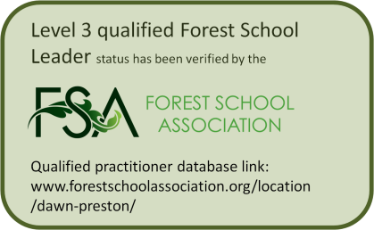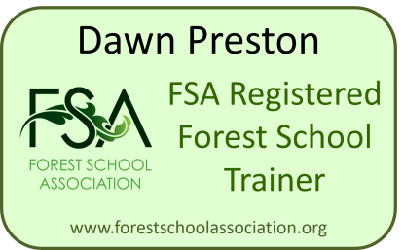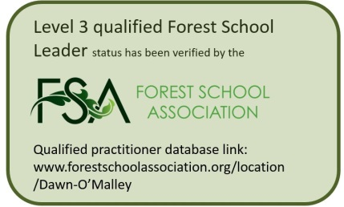
 | Forest School Experience Day | Forest School Level 1 | Forest School Level 2 | Forest School Level 3
Description of training | Taster days are held on a regular basis at our woodland nature reserves across Hampshire and the Isle of Wight. Led by one of our Level 3 Forest School leaders, the day provides the learner with the opportunity to take part in a Forest School session, trying activities such as fire lighting, shelter building, campfire cooking, natural art and crafts and more. The sessions are practical and take place outside from 1000 until1600, usually on a Saturday.  We can also deliver bespoke sessions for up to fifteen learners, focussing on how Forest School can support different areas of the curriculum or individuals with behaviour / attention disorders and those with special or additional needs.  Please get in touch for further details. | The Level 1Award in Forest School Ethos and Principles provides learners with an introduction to the Forest School ethos as well as the opportunity to develop skills such as  - tool use  - environmental games and activities  - risk assessment  - an introduction to woodland management.  The course is led by a member of our Forest School training team and takes place over two consecutive days, from 1000 until 1600. The sessions will take place outdoors in one of our woodland nature reserves. | The Level 2 Forest School training course offers a more in depth look at the Forest School ethos and qualifies learners to become Assistant Forest School Leaders, supporting a Level 3 Leader to run Forest School programmes. The course will take you through the Forest School approach to learning and the principles of risk management. Learners will have the opportunity to develop their practical skills, including  - safe lighting, management and use of a campfire  - safe use of a range of hand tools  - delivery of a variety of games and activities  - identification of woodland flora and fauna  - the sustainable use of woodland within the context of Forest School.  The course will be run on Forest School principles, so you will experience the Forest School ethos first hand. The course will be led by a member of our Forest School training team and takes place over four consecutive days from 0930 until 1630 in one of our woodland nature reserves. | The Level 3 Certificate for Forest School Leaders prepares participants to set up their own Forest School provision, planning, delivering and monitoring all aspects of a Forest School programme, including  •How to plan and deliver an Introductory Forest School programme.  •Current theories on the Forest school approach to learning and development.  •How to identify, assess and manage risk at Forest School.  •Safe use of a range of hand tools and associated skills.  •How to light, manage and use a campfire in a Forest School setting.  •A range of outdoor games and activities which promote environmental awareness and connection with nature and wellbeing.  •Identification of woodland flora and fauna.  •The sustainable use of a woodland within the context of Forest school.  The course will be run on Forest School principles, so you will have experience of the Forest School ethos. Training days run from 0930 until 1630 at one of our woodland nature reserves and as much time as possible will be spent outdoors
Course content | Wholly practical outdoor session, variable in nature according to the season, weather conditions and requirements of the group. | •Two day training programme  •Level 1 workbook to be completed within one month of the start date  •Attendance at a Forest School session led by a Level 3 Forest School leader (we can put you in touch with a suitable person if required).  •A written record of your observations at Forest School. | •Four day training programme  •Level 2 workbook to be completed within 6 months of the start date  •Assist with three Forest School sessions led by a Level 3 Forest School leader (we can put you in touch with a suitable person if required).  •A written record of your observations at Forest School. | •Five days of training in Forest School theory and practice.  •A coursework portfolio which should be completed within twelve months of the course start date.  •Three portfolio days assist learners with coursework and offer support with the development of your Forest School programmes.  •2 skills days to develop and assess practical skills and to discuss progress.  •Learners are required to plan and deliver an introductory Forest School programme of six sessions with their chosen client group and will be assessed on one of the sessions by a member of our Forest School training team. The programme should take place within twelve months of the course start date.
Who the course is for | The course is for people with limited or no previous experience of Forest School who would like to find out more. | Member of Forest School staff team: Those with a Level 1 qualification would be able to join the staff team of an established Forest School, helping to plan and deliver sessions and support learners. It can also be used as a first step for those considering taking Forest School Leader training at a later date. | Assistant Forest School leader: This course is designed for individuals wishing to assist with the delivery of Forest School programmes, supporting sessions led by a Level 3 practitioner. | Forest School Leader: This course is the nationally recognised standard of training for individuals wishing to lead and manage a Forest School programme.
Entry criteria | N/A | •Participants must be over 16 years of age.  •Participants should have an interest in working outdoors with children and young people. | •Participants should be over 18 years of age.  •Participants should have experience of working with children or young people.  •Participants should be DBS checked. | •Participants should be over 21 years of age.  •Participants should hold a qualification at Level 2 or above in teaching, pre-school education, youth work or countryside skills.  •Participants should have significant experience of working with young people.  •Participants must be DBS checked within the last 3 years.  •Participants must hold a First Aid certificate by the end of the course. This can be the 16-hour Outdoor or Forest School First Aid certificate N.B. If you work with under 5’s, the EYFS guidelines require staff to also hold a Paediatric First Aid Certificate. Alternatively the 16 hour Forest School First Aid with Paediatric First Aid is approved by the Department for Education.
Accreditation | The course is not accredited but you will receive a certificate of attendance from HIWWT. | On successful completion of the course you will be awarded a LASER Level 1 Award in the Forest School Ethos and Principles (RQF). We expect the course to take you about three months to complete. | On successful completion of the course, including work book, you will be awarded the LASER Level 2 Award for Forest School Assistants (RQF). We expect the course to take you about a year to complete. | On successful completion of the course you will be awarded the LASER Level 3 Certificate for Forest School Leaders (RQF) which is a nationally recognised qualification and is compatible with the FSA Accredited Forest School Provider Scheme. You will receive your certificate on successful completion of your coursework portfolio, your planned sessions and the practical skills weekend.
What you need to bring | •A packed lunch and a cup for hot drinks.  •Suitable outdoor clothing for the weather conditions (trousers, not shorts, and a long-sleeved top). Several thin layers are more effective at keeping you warm than one thick layer. Remember that you will be spending the day in the shade of the trees.  •Waterproof jacket and trousers, together with a woolly hat and gloves if it’s cold. Sun cream and hats if needed.  •Stout shoes or boots with socks. For your comfort and safety, please do not wear sandals or trainers.  •A notebook, pen and camera for recording information and activities | As for experience day | As for experience day | Once your booking is confirmed you will be sent a full kit list (including details of the practical skills weekend), but for each day of training you will need to bring with you the recommended equipment for an experience day.
What we will provide | •Hot drinks and snacks.  •All tools and equipment for the outdoor tasks. Please DO NOT bring your own tools with you, including knives. | As for experience day | As for experience day | As for experience day.
Supporter requirements | None required | To enable and support the trainee to shadow a Forest School session led by a local provider to complete a written observation within 2 months of the course start date. This may be through releasing the trainee during work hours to attend.  Should the trainee fail to complete the portfolio coursework within the given 3 month deadline, the Trust charge £50 per month extension. Please see the learner agreement for full details. | To enable and support the trainee to assist at 3 consecutive Forest School sessions led by a local provider to complete the written portfolio work within 6 months of the course start date. This may be through releasing the trainee during work hours to attend.  Should the trainee fail to complete the portfolio coursework within the given 3 month deadline, the Trust charge £50 per month extension. Please see the learner agreement for full details. | The trainee is required to plan, deliver and evaluate a 6 session Forest School programme for a group. The supporter agrees to support the trainee to prepare the FS handbook by sharing current setting information, such as insurance details, health & safety documents etc. and supporting the trainee to develop Forest School specific health and safety documentation. This may be through regular meetings, time allowed during work hours to complete documentation etc.  The supporter will also enable the trainee to deliver 6 Introductory Forest School sessions to a suitable client group, following the FS principles, ethos and criteria (i.e. low child to staff ratios to enable risky play opportunities, delivering a child led ethos, in a wooded environment etc. Please see http://www.forestschoolassociation.org/full-principles-and-criteria-for-good-practice/ )  Should the trainee fail to deliver the observed session demonstrating good practice outlined above, the Trust will impose an additional charge of £50 for a second observation visit. Should the trainee fail to complete the portfolio coursework within the given 1 year deadline, the Trust will charge £100 per month extension. Please see the learner agreement for full details.

